SAMPLE - An example of how to fill out the article submission form before emailing it to OnlineAuthors@gmail.com
About you: -
Your Full Name (published) | John Donald
Email (published)  Email us from this account only | John.Donald.1298@gmail.com  NOTE: Email us from this email address otherwise we will not accept your submission.  Your email address is published inside your article.
Street Address  (Optional NOT published or shared, just for our reference) | 1st Floor,  123 Main Street, Near BOA bank (You may leave address empty if you want)
City: (published) | Los Angeles
State / Zip: (published) | California, 92002
Country: (published) | USA
A few lines about you:  (published) | I am currently pursuing MS in Microbiology from University of Los Angeles. I have also worked with Genentech as a research assistant for 2 years.
Phone:  (Optional - NOT published or shared, just for our reference) | 1-650-600-0000 (You may leave phone number empty if you want)
Existing Author | No

Your Article:
Article Title  (3 to 12 words) | Future of High Efficiency Gene Therapy
Article Summary  (In short - What is your article about – Just 2 or 3 lines) | The basic philosophy of the gene therapy is to replace the mal-functioning/mutated gene with a normal gene. One of the targeted approach is to transfer the required gene into the target cells by taking them out of the body and them conducting an in-vitro transfer to the cultured cells.
Category: | Genetics

Your full article ( between 500 to 5000 words) - - Do check for grammatical errors or spelling mistakes
Since the day, Ashanti Desilva, a four year old little girl from United States, suffering from ADA SCID (an immune deficiency disease) was operated by the first ever gene therapy attempt in the medical history in 1990, a lot has happened in the field of Gene Therapy. Speculations were always rife about the fatal consequences of Gene Therapy (alteration of normal genetic make-up, physiological rejection etc), but they could never out-weigh the foreseen advantages of permanent cure of diseases as deadly as Cancer.

Our physiology is an outcome of the housekeeping genes, or in better words, our normal physiology is an outcome of the normal functioning of the housekeeping genes expressing round the clock in our system (body). Whereas, the house keeping genes ensure the optimal functioning of metabolic pathways ranging from DNA synthesis to food digestion, there are another set of genes called oncogenes (cancer causing genes) whose dormancy is extremely crucial for the normal functioning of the system. In dormant (or inactive) state, these oncogenes are termed proto-oncogenes and are unable to exert their effect i.e uncontrolled cell division. And, any mutation in either the house keeping genes or proto-oncogenes, can severely harm the normal functioning of the physiological system, manifested in the form of diseases like Thalassemia, Sickle Cell Anemia and numerous forms of cancers etc. This is where gene therapy pronounces itself as the most efficient and lasting cure for such fatal diseases; because it’s always best to remove the cause than to treat the symptoms.

The basic philosophy of the gene therapy is to replace the mal-functioning/mutated gene with a normal gene. In words, it might seem as simple as swapping an old ball with a new one, but in practice gene swapping is the most ambitious treatment for any disease, whose chances of success are as low as tracing a needle in the haystack! A successful gene therapy has numerous check lists to follow, missing a single pre-requisite can mar the attempt and rather pose threat to the subject. One of the most important requirement in gene therapy is targeted delivery of the gene(s) to the genome of the cell(s), it’s intended to swap genes with. As in the case of ADA SCID of Ashanthi, one of the targeted approach is to transfer the required gene into the target cells by taking them out of the body and them conducting an in-vitro transfer to the cultured cells. This approach, called ex-vivo, requires extraction of the desired cell(s) from the body, a high class culturing facility for the cells and then a mechanism for regular injection of those cells in the body at the extracted location, making it inherently cumbrous. Other method, the in-vivo mode of gene delivery, involves direct injection of the transgene into the body through various routes, with an aim of site-specific delivery, integration and expression of the gene of interest. Now, the term direct injection shouldn't be misinterpreted, as the DNA/transgene cannot be injected as such in naked form. A naked DNA may be treated as an antigen and defense response may be initiated by the body to wipe the antigen. Apart from that, various nucleases present in the body fluids/cells may degrade the naked DNA much before its anticipated delivery to the target site.

Modes of In-vivo Targeted Gene Delivery
The in-vivo procedure can utilize two modes of delivering the transgene to the target site:

Procedure 1 | Procedure 2
Viral Mode | Non-Viral Mode

Viral mode exploits the ability of viral vectors to integrate their DNA into the host genome, and replicating with the host thereafter. This is one of the most efficient mode of gene transfer in terms of the probability of successful gene integration and expression. But the concern over the use of Viral vectors in Humans has always been a roadblock in this regard.
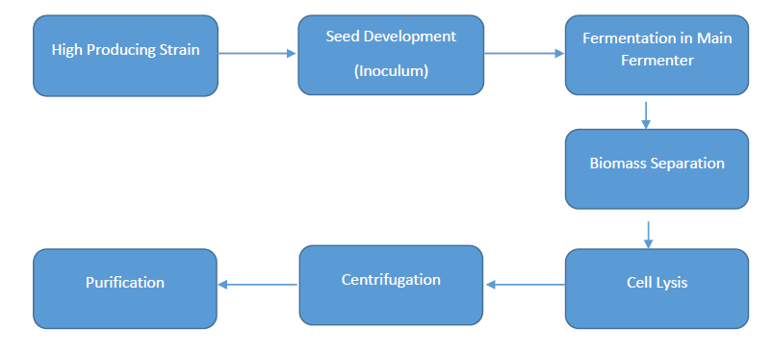
Image Source: http://farm9.staticflickr.com/8536/8694451695_e9c77d42aa.jpg
Considering the limitation of viral vectors, numerous attempts have been made in developing an efficient non-viral mode of gene delivery. Use of gene gun, polyplexes and lipoplexes, are some of the conventionally tried methods to deliver genes into the cells. But considering the stringent requirement of the gene therapy, the rate of success with such physical methods is very low. It is equally probable that the gene carrying complex may reach at an unintended site and integrate the DNA in the normal cells causing adverse side effects. The obvious challenge in using these physical means of delivery lies in targeted delivery of the delivery complex. In order to achieve a site specific delivery, tagging of these complexes with some ligands complementary to the surface antigens of the targeted cells is the most common and efficient approach. Infact, ligand tagged nanoparticles have emerged as the complexes of choice for delivering the genes to the target site. For example, Tissue Factor (TF) expressed by injured cells of the body has become an address of choice for nanoparticle mediated drug and gene delivery to the injured tissue inside the body. EGFP-EGF1 is tagged on the nanoparticles which owing to it’s affinity towards TF directs the nanoparticles carrying the drug/gene payload to the injured site. The nature of nanoparticles under use in most cases is PLGA or poly(lactic-co-glycolic acid), which exhibits extraordinary biocompatibility and biodegradability. In a recent publication by Department of Surgery, Guangdong Provincial Stomatological Hospital, Southern Medical University, Guangzhou, People's Republic of China, use of Quantum Dots (QDs) as vectors for targeted survivin gene siRNA delivery was reported. Use of QDs enables real time probing of the successful gene delivery and it’s expression levels. For those who are unaware of the concept of QDs, these are tiny nano-particles with a size range of 2-10nm and are chemically selenides of cadmium or zinc. Their extra-ordinary small size enables unique electrical and optical properties, which can be studied in the form of photonic emissions.

Evidently, a lot of progress has taken place in the field of targeted gene delivery for an efficient gene therapy. New approaches like ligand coated Nanoparticles and use of Quantum Dots exhibit some of the big achievements in this field in a period as short as just 2 decades. With the widening scope of targeted delivery, diseases like advanced Cancer and even HIV have been reportedly cured in some instances. And, the scope will keep expanding it’s horizons with increasing knowledge of genetic behavior of diseases and newer means of delivering the medicinal gene to the diseased site.

References (if any)
- www.ndsu.edu/pubweb/~mcclean/plsc431/students98/fleck.htm
- Human Gene Therapy: Current Opportunities and Future Trends - Page 176 - By G. M. Rubanyi

Terms - Do not remove or change this section ( It should be emailed back to us as is)
